***Exercise Questions***

QUESTION # 1: Take a number as an input from a user. Check if the number is an even number or an odd

number. Draw a flowchart on your notebook. Convert the flowchart into scratch diagram.

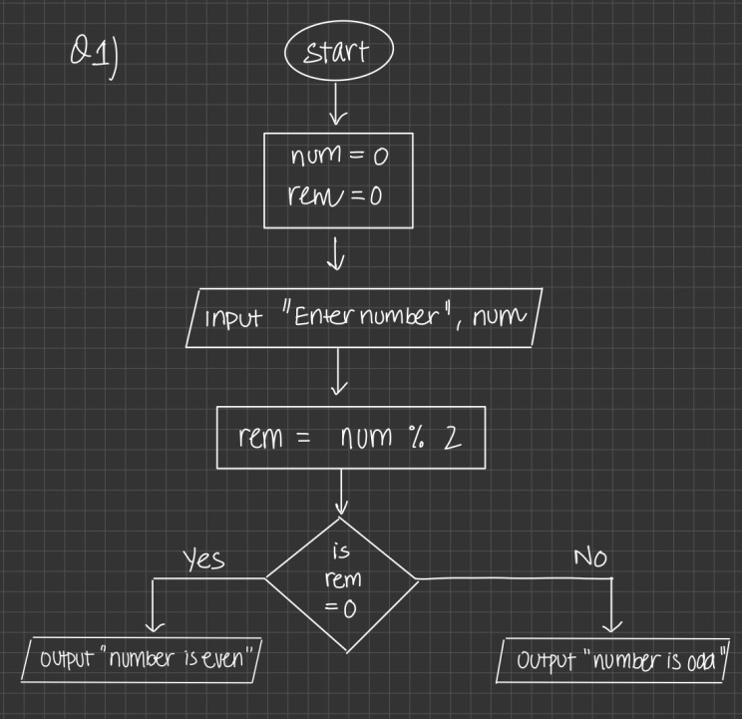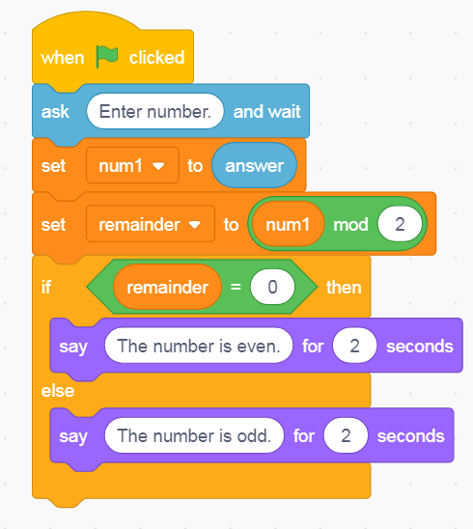

QUESTION # 2: You are supposed to create a mark sheet. There are total five subjects. Each subject has equalmarks i.e., 100, therefore total marks are 500. Take marks of five subjects as an input from the user. Calculatethe percentage. If the percentage is below 50, he/she is pass else he/she is fail. Draw a flowchart on yournotebook. Convert the flowchart into scratch diagram.

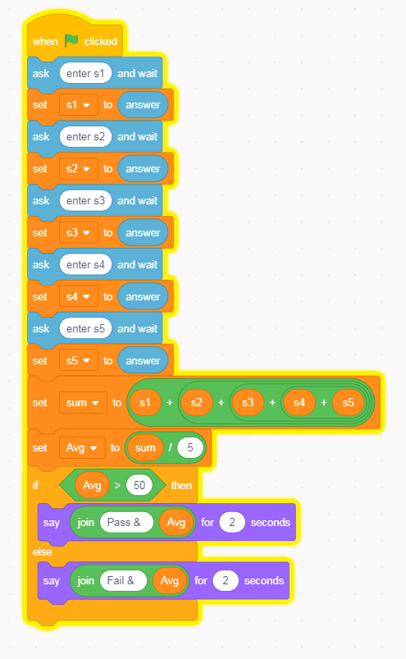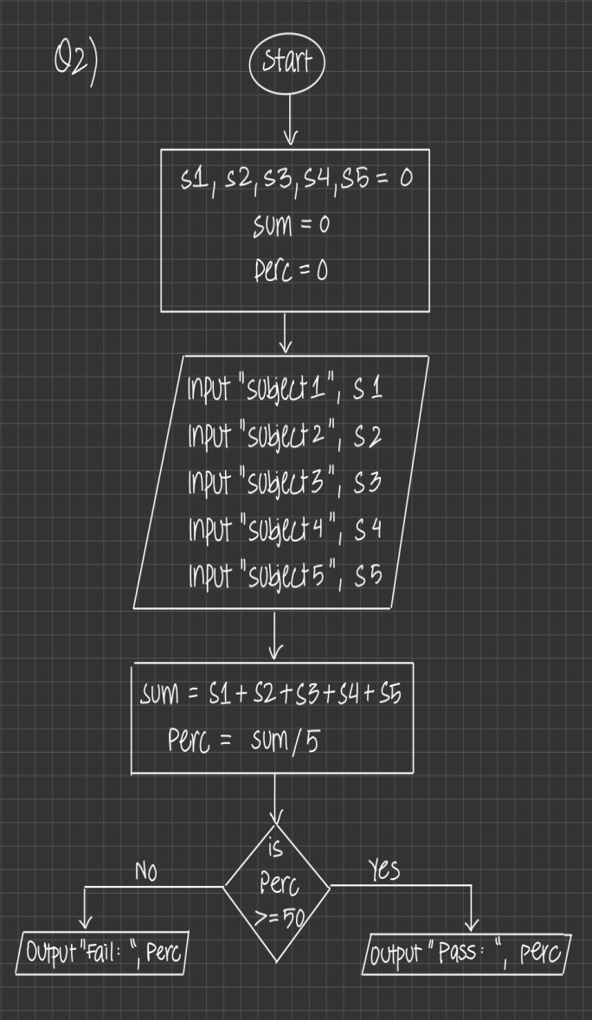

QUESTION # 3: Draw a hexagon that has six sides. Repeat the hexagon for the same number of times as of its size.

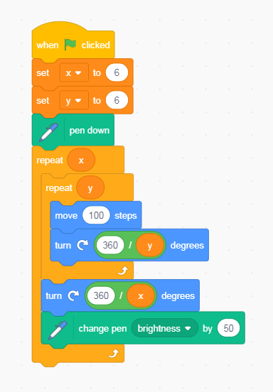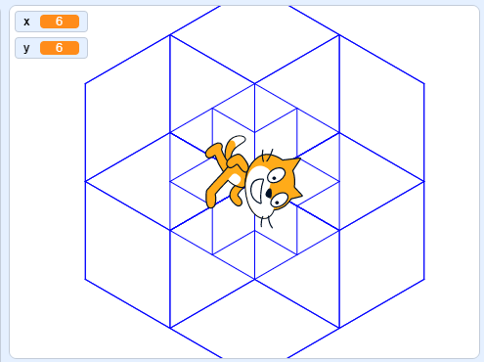

(sorry I made multiple hexagons, p.s : the undo process wasn’t taking place.)

QUESTION # 4: Given below is a flow chart. Identify the decision and iterative structures in it. Convert theflow chart in to scratch diagram.

The iterative structure repeatedly do the task as long as condition is true ( x is less than 10 ). As soon as x gets greater than 10 due to increment, the loop exits and flowchart ends.

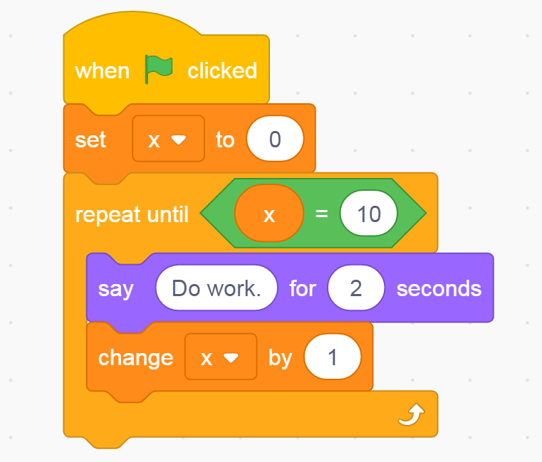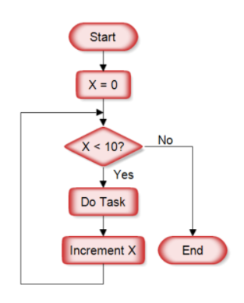

QUESTION # 5: Given below is a scratch diagram. Write a description of the diagram as well as draw it’s flowchart on your notebook.

The variable “some number” is assigned the value of 42. The IF condition gets true 2 times then flow shifts to the second statement as the ELSE statement is served 2 times after which finally “some number” gets equal to 28 causing the REPEAT UNTIL statement to get true which stops the flowchart.

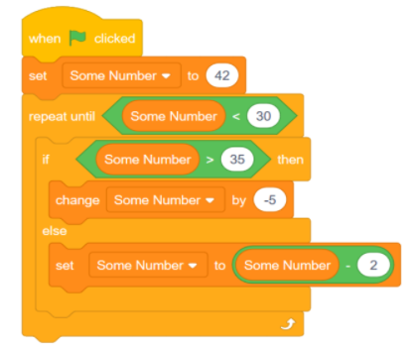

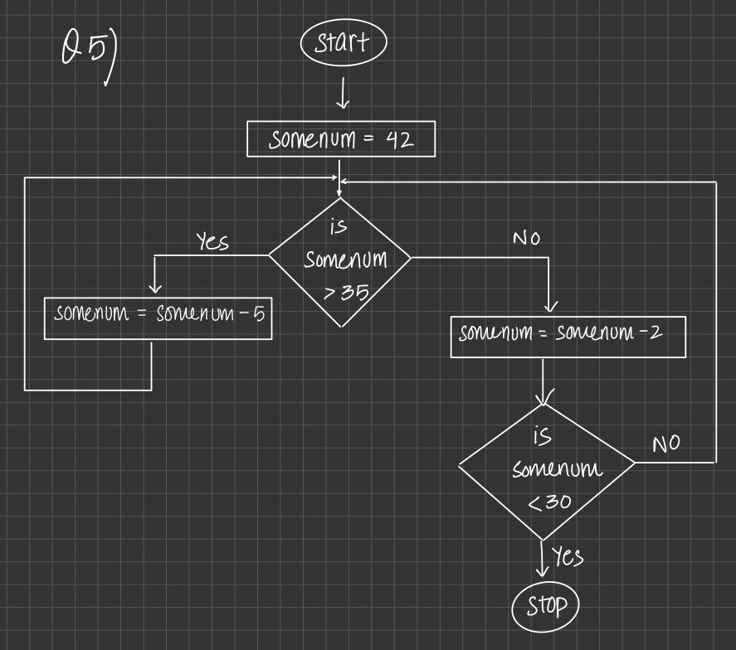

QUESTION # 6: Create a scratch program that takes a number from user and prints its table till 20.

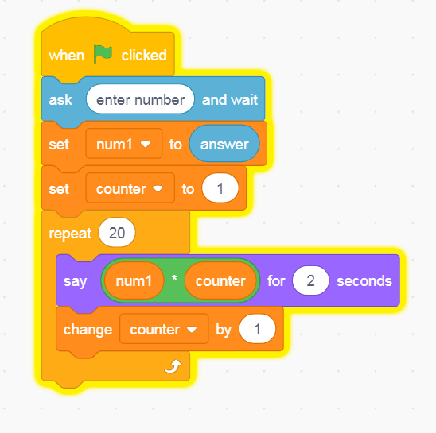

QUESTION # 7: Create a scratch program where you display a conversation between two characters. The

story should have at least 5 dialogues for each character.

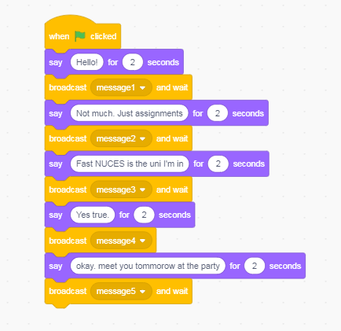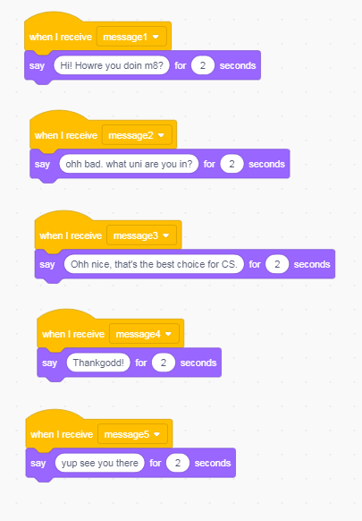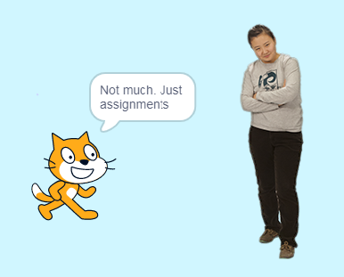

QUESTION # 8: Create a translate application in which user enters a sentence and your program should

translate that sentence into any foreign language (e.g. Arabic, French, etc.)

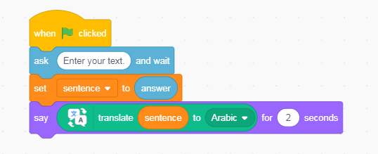

QUESTION # 9: Create a scratch program that takes an alphabet from user and decides whether that alphabetis a vowel or a consonant.

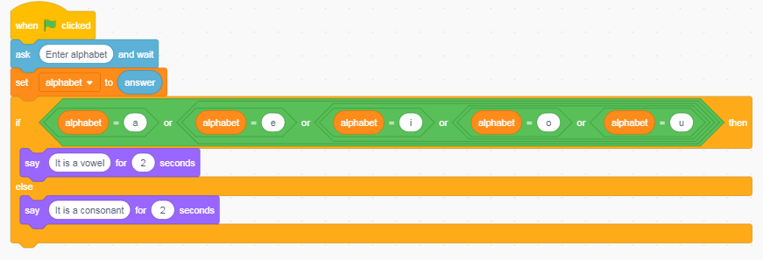

QUESTION # 10: Create a scratch program that prints Fibonacci series till 8 digits.

Fibonacci Series: 1,1,2,3,5,8,13,21......

